**DEPARTMENT OF INFORMATION TECHNOLOGY**

**COURSE CODE: DJS22ITL307 DATE:**

**COURSE NAME: Web Programming Laboratory CLASS: SY Btech**

**NAME : Anish Sharma**

**EXPERIMENT NO. 6**

**CO/LO:** Develop web applications.

**AIM / OBJECTIVE:** Event Handling using Java Script

**THEORY:**

The change in the state of an object is known as an Event. In html, there are various events which represents that some activity is performed by the user or by the browser. When [javascript](https://www.javatpoint.com/javascript-tutorial) code is included in [HTML](https://www.javatpoint.com/html-tutorial), js react over these events and allow the execution. This process of reacting over the events is called Event Handling. Thus, js handles the HTML events via Event Handlers.

For example, when a user clicks over the browser, add js code, which will execute the task to be performed on the event.

Some of the HTML events and their event handlers are:

**Mouse events:**

|  |  |  |
| --- | --- | --- |
| Event Performed | Event Handler | Description |
| click | onclick | When mouse click on an element |
| mouseover | onmouseover | When the cursor of the mouse comes over the element |
| mouseout | onmouseout | When the cursor of the mouse leaves an element |
| mousedown | onmousedown | When the mouse button is pressed over the element |
| mouseup | onmouseup | When the mouse button is released over the element |
| mousemove | onmousemove | When the mouse movement takes place. |

**Keyboard events:**

|  |  |  |
| --- | --- | --- |
| Event Performed | Event Handler | Description |
| Keydown & Keyup | onkeydown & onkeyup | When the user press and then release the key |

**Form events:**

|  |  |  |
| --- | --- | --- |
| Event Performed | Event Handler | Description |
| focus | onfocus | When the user focuses on an element |
| submit | onsubmit | When the user submits the form |
| blur | onblur | When the focus is away from a form element |
| change | onchange | When the user modifies or changes the value of a form element |

**Window/Document events**

|  |  |  |
| --- | --- | --- |
| Event Performed | Event Handler | Description |
| load | onload | When the browser finishes the loading of the page |
| unload | onunload | When the visitor leaves the current webpage, the browser unloads it |
| resize | onresize | When the visitor resizes the window of the browser |

**Code:**

1. Write a JavaScript function that changes the background color of an element when a mouse enters it.
2. Write a JavaScript program that adds a keydown event listener to a text input to detect when the "Enter key" is pressed.

<html>

<head>

    <meta charset="utf-8">

    <title>

        How to Change Background Color

        of a Div on Mouse Move Over

        using JavaScript ?

    </title>

    <style>

        .first {

            position: absolute;

            background: #E73C49;

            width: 300px;

            height: 300px;

            top: 50%;

            left: 50%;

            transform: translate(-50%, -50%);

        }

        h2,

        .key {

            text-align: center;

            justify-content: center;

            justify-items: center;

            margin-top: 7rem;

        }

    </style>

    <link href="https://cdn.jsdelivr.net/npm/bootstrap@5.3.2/dist/css/bootstrap.min.css" rel="stylesheet"

        integrity="sha384-T3c6CoIi6uLrA9TneNEoa7RxnatzjcDSCmG1MXxSR1GAsXEV/Dwwykc2MPK8M2HN" crossorigin="anonymous">

</head>

<body>

    <div class="first">

        <h2>Let sing a song</h2>

        <div class="key">

            <p>Press a key in the input field:</p>

            <input type="text" onkeydown="myFunction1()" onkeyup="myFunction2()">

            <p id="demo"></p>

        </div>

    </div>

    <script type="text/javascript">

        var color = [, "#3C9EE7", "#E7993C",

            "#E73C99", "#3CE746", "#E7993C"];

        function myFunction1() {

            document.getElementById("demo").innerHTML = "You pressed a key inside the input field";

        }

        function myFunction2() {

            document.getElementById("demo").innerHTML = "You are not a pressed a key inside the input field";

        }

        document.querySelector("div").addEventListener(

            "mouseover", function () {

                document.querySelector("div").style.background

                    = color[(Math.floor(Math.random() * color.length))];

            })

    </script>

    <script src="https://cdn.jsdelivr.net/npm/@popperjs/core@2.11.8/dist/umd/popper.min.js"

        integrity="sha384-I7E8VVD/ismYTF4hNIPjVp/Zjvgyol6VFvRkX/vR+Vc4jQkC+hVqc2pM8ODewa9r"

        crossorigin="anonymous"></script>

    <script src="https://cdn.jsdelivr.net/npm/bootstrap@5.3.2/dist/js/bootstrap.min.js"

        integrity="sha384-BBtl+eGJRgqQAUMxJ7pMwbEyER4l1g+O15P+16Ep7Q9Q+zqX6gSbd85u4mG4QzX+"

        crossorigin="anonymous"></script>

</body>

</html>

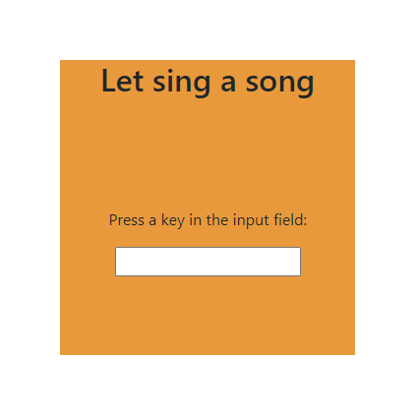

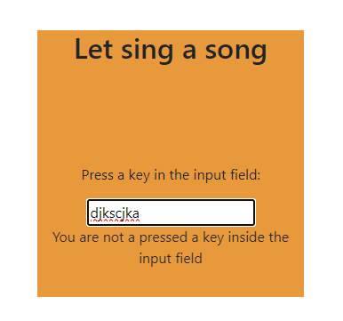

1. Write a code to display the input from user in the registration form onsubmit.
2. <!DOCTYPE html>
3. <html>
4. <head>
5. <style>
6. body {
7. font-family: Arial, sans-serif;
8. background-color: #f4f4f4;
9. }
10. form {
11. max-width: 300px;
12. margin: 0 auto;
13. background: #f9f9f9;
14. padding: 20px;
15. border: 1px solid #c3c3c3;
16. }
17. input[type="text"] {
18. width: 100%;
19. padding: 12px 20px;
20. margin: 8px 0;
21. display: inline-block;
22. border: 1px solid #ccc;
23. border-radius: 4px;
24. box-sizing: border-box;
25. }
26. input[type="submit"] {
27. width: 100%;
28. background-color: #4CAF50;
29. color: white;
30. padding: 14px 20px;
31. margin: 8px 0;
32. border: none;
33. border-radius: 4px;
34. cursor: pointer;
35. }
36. input[type="submit"]:hover {
37. background-color: #45a049;
38. }
39. </style>
40. <script>
41. function displayInput() {
42. var name = document.getElementById("name").value;
43. var email = document.getElementById("email").value;
44. var phone = document.getElementById("phone").value;
45. var address = document.getElementById("address").value;
46. // Displaying the input values
47. alert("Name: " + name + "\nEmail: " + email + "\nPhone: " + phone + "\nAddress: " + address);
48. }
49. </script>
50. </head>
51. <body>
52. <h2 style="text-align: center;">Registration Form</h2>
53. <form onsubmit="displayInput()">
54. Name:<br>
55. <input type="text" id="name" name="name">
56. <br>
57. Email:<br>
58. <input type="text" id="email" name="email">
59. <br>
60. Phone:<br>
61. <input type="text" id="phone" name="phone">
62. <br>
63. Address:<br>
64. <input type="text" id="address" name="address">
65. <br><br>
66. <input type="submit" value="Submit">
67. </form>
68. </body>
69. </html>

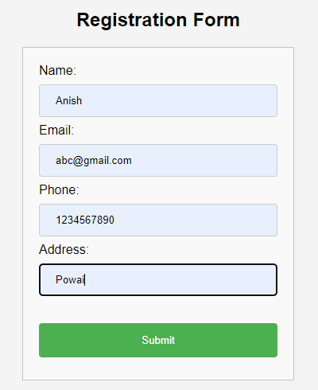

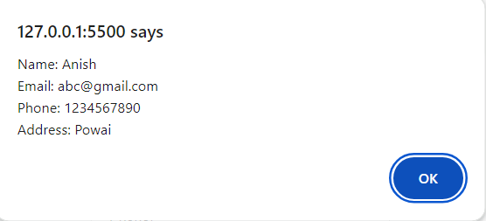

**BOOKS AND WEB RESOURCES:**

1. Tailwind CSS From Scratch | Learn By Building Projects by Brad Traversy

2. Tailwind CSS: A Modern Way To Build Websites Using CSS